PROJECT DOCUMENTATION

EV Market Performance
& Sustainability Analytics
An interactive Tableau dashboard for exploring electric-vehicle market indicators

Project Type | Data Analytics and Visualization
Technology | Tableau Public / Tableau Desktop
Team ID | Individual
Documentation Date | 27 October 2026
Prepared from the supplied Tableau dashboard screenshots and project description

Contents
- 1. Executive Summary
- 2. Introduction and Background
- 3. Problem Statement
- 4. Project Objectives
- 5. Scope and Stakeholders
- 6. Dataset and Technology Stack
- 7. Methodology and Workflow
- 8. Dashboard Design and Visualizations
- 9. Key Metrics and Observations
- 10. Interactivity and Usability
- 11. Testing and Data Quality Considerations
- 12. Limitations and Future Enhancements
- 13. Conclusion
- 14. Dashboard Link
- Appendix A. Dashboard Screenshots

1. Executive Summary
EV Market Performance & Sustainability Analytics is a Tableau-based data visualization project designed to present electric-vehicle market measures in an interactive dashboard. The workbook brings together headline KPIs, year-wise sales trends, manufacturing-country comparisons, vehicle-category sales mix, battery-technology mix, manufacturer comparisons, driving-range distributions, a country/category heatmap, and a charging-speed versus energy-efficiency scatter plot.
The dashboard screenshots show four headline values: approximately 1.55B total sales units, an average vehicle price of $64,921, an average driving range of 324.54 km, and annual CO₂ savings of 737.93K tonnes. These are reported as displayed in the workbook and should be interpreted according to the dataset's definitions, record grain, units, and aggregation settings.

2. Introduction and Background
The electric-vehicle industry is developing rapidly as manufacturers and governments respond to environmental concerns, clean-energy goals, technological improvements, and changing consumer demand. EV performance and adoption are influenced by vehicle category, pricing, driving range, battery technology, charging capability, manufacturer performance, and regional market activity.
These measures can be difficult to compare when they are spread across rows and columns in a dataset. A visual analytics dashboard makes the information easier to scan, compare, and discuss. This project uses Tableau to organize the supplied EV dataset into a set of complementary views.

3. Problem Statement
Stakeholders need a clear way to compare EV sales across model years, vehicle categories, manufacturing countries, and battery technologies while also reviewing price, range, charging, efficiency, manufacturer, and environmental indicators. Without a consolidated view, it takes more effort to identify patterns and investigate areas that deserve further analysis.

4. Project Objectives
- Present headline EV market indicators through KPI cards.
- Compare annual sales patterns across model years and vehicle categories.
- Compare recorded sales by manufacturing country.
- Explore sales distribution across vehicle categories and battery technologies.
- Examine driving-range distributions and manufacturer-related measures.
- Explore country/category patterns with a heatmap.
- Visualize charging power against the displayed energy-efficiency measure.
- Provide a clear dashboard layout that can support discussion and further analysis.

5. Scope and Stakeholders
The documented scope covers the supplied dataset and the Tableau views visible in the screenshots. It does not assume a separate database, live feed, predictive model, or external data pipeline.
Stakeholder | Analytical Need
Market Strategy Director | Compare vehicle-category sales and identify segments for further strategic investigation.
Business Intelligence Manager | Compare country, manufacturer, sales, and battery-related measures.
Sustainable Mobility Research Analyst | Explore range, battery technologies, charging/efficiency, and recorded CO₂-saving measures.

6. Dataset and Technology Stack
The project uses the EV market dataset supplied by the project owner and connected to Tableau. The screenshots show fields or measures associated with annual sales units, model year, vehicle category, manufacturing country, battery type, vehicle price, driving range, maximum DC charging power, energy efficiency, battery capacity, customer rating, and CO₂ savings.
Component | Description
Data source | Supplied CSV/Excel dataset (exact filename, record count, and file size should be confirmed from the source file).
Visualization tool | Tableau Desktop / Tableau Public.
Dashboard components | KPI cards, line chart, horizontal bar chart, donut charts, bubble/scatter chart, range distribution, and heatmap.
Publishing | Tableau Public dashboard link supplied by the project owner.

7. Methodology and Workflow
Connect the dataset: Connect the supplied structured data file to Tableau and review the available fields.
Inspect and prepare fields: Check field roles and data types, inspect missing values and inconsistent labels, and confirm units.
Create measures and KPIs: Use appropriate aggregations for total sales, average price, average range, and the supplied CO₂-saving measure.
Build worksheets: Create the trend, country comparison, category and battery donut charts, manufacturer comparison, range distribution, heatmap, and scatter plot.
Assemble dashboards: Arrange the worksheets into two dashboards and place the KPI cards and legends/filters for convenient reading.
Validate the views: Test filters, tooltips, labels, totals, percentage calculations, and the axes of charts before presenting conclusions.
Publish and document: Publish the dashboard to Tableau Public and provide the public link in the final section.

8. Dashboard Design and Visualizations
The workbook is organized into two dashboards. Dashboard 1 focuses on the headline metrics and sales mix; Dashboard 2 focuses on manufacturer performance, range distribution, country/category patterns, and charging/efficiency.
Visualization | Purpose
KPI cards | Summarize total EV sales, average vehicle price, average driving range, and annual CO₂ saved.
Sales trend line chart | Compares annual sales units across model years and vehicle categories.
Manufacturing-country bar chart | Compares recorded annual sales units across countries.
Vehicle-category donut chart | Shows the contribution of each vehicle category to the displayed sales total.
Battery-technology donut chart | Shows the displayed sales share for LFP, NCA, NMC, Sodium-Ion, and Solid-State battery types.
Manufacturer performance bubble chart | Compares sales and a customer-rating measure; validate the rating field and aggregation before ranking manufacturers.
Driving-range distribution | Shows the range distribution across vehicle categories.
Country/category heatmap | Uses colour intensity to compare the sales measure across manufacturing countries and vehicle categories.
Charging speed vs energy efficiency scatter plot | Explores the relationship between maximum DC charging power and the displayed efficiency measure, with battery capacity represented by mark size.

9. Key Metrics and Observations
Metric | Displayed Value | Interpretation / Check
Total sales | 1.55B | Displayed total sales measure; confirm what one sales unit represents.
Average vehicle price | $64,921 | Displayed average price; confirm currency and treatment of missing prices.
Average driving range | 324.54 km | Displayed average range measure.
Annual CO₂ saved | 737.93K tonnes | Displayed annual CO₂-savings measure; confirm the underlying calculation and units.
Battery technology mix | NMC 33.80%; LFP 31.99%; NCA 17.23%; Sodium-Ion 9.88% | Shares visible in the supplied screenshot; Solid-State accounts for the remaining displayed share, subject to rounding.
The country comparison shows India and China among the leading displayed countries in the earlier dashboard view. The exact ranking may vary with filters and the country measure used. The charts are descriptive; they do not prove that battery technology, country, or charging power causes higher sales or better performance.

10. Interactivity and Usability
- Category filter: use it to focus the dashboard on selected vehicle categories, after confirming which worksheets it controls.
- Model Year filter: narrow the displayed period to compare selected years.
- Tooltips: hover over marks to inspect available details and values.
- Device Preview: check the dashboard at desktop and phone sizes before claiming responsive behavior.
- Cross-filtering: mention only interactions that are enabled and tested in the published workbook.

11. Testing and Data Quality Considerations
- Confirm the source field names and data types in Tableau.
- Record actual row count, file size, missing-value count, and duplicate count from the source rather than estimating them.
- Confirm the record grain before summing Annual Sales Units to avoid double-counting.
- Verify the units and aggregation of price, driving range, charging power, efficiency, battery capacity, and CO₂ savings.
- The manufacturer chart screenshot shows a customer-rating axis in the thousands; check whether the field is being summed instead of averaged or otherwise incorrectly aggregated.
- The charging/efficiency scatter plot shows very large efficiency values; validate the field, unit, aggregation, and axis labels before interpreting it.
- Test filter behavior, battery-share percentages, KPI totals, and dashboard load time with repeated runs.
- Do not claim measured query execution times or performance improvements unless actual measurements are recorded.

12. Limitations and Future Enhancements
- Validate the data dictionary, record grain, units, and KPI definitions.
- Correct or relabel the manufacturer customer-rating measure if its current aggregation is inappropriate.
- Validate the charging-efficiency field and ensure its unit matches the displayed axis.
- Add documented data-quality results, such as actual null and duplicate counts.
- Improve mobile layout after testing Tableau Device Preview.
- Add a Tableau Story with a verified sequence of story points if narrative presentation is required.
- If future work includes forecasting or statistical testing, document the method and assumptions separately from the current descriptive dashboard.

13. Conclusion
The EV Market Performance & Sustainability Analytics project consolidates multiple EV market measures into an interactive Tableau dashboard. Its KPI cards and complementary charts support exploration of sales trends, country comparisons, vehicle-category mix, battery technologies, range, manufacturer measures, and sustainability indicators. Before using the dashboard for formal decisions, the data definitions, aggregations, units, and unusual axis scales should be validated. With these checks, the workbook can serve as a clear visual starting point for market analysis and stakeholder discussion.

14. Dashboard Link
Public Tableau dashboard:
https://public.tableau.com/app/profile/sudhanshu.gangrade/viz/ElectricVehicleMarketPerformanceInsights_17931158571440/Dashboard1?publish=yeshttps://public.tableau.com/app/profile/sudhanshu.gangrade/viz/ElectricVehicleMarketPerformanceInsights_17931158571440/Dashboard1?publish=yes

Appendix A. Dashboard Screenshots
Figure A1. Main EV Market Performance dashboard with KPI cards, sales trend, manufacturing-country comparison, vehicle-category donut, and battery-technology donut.
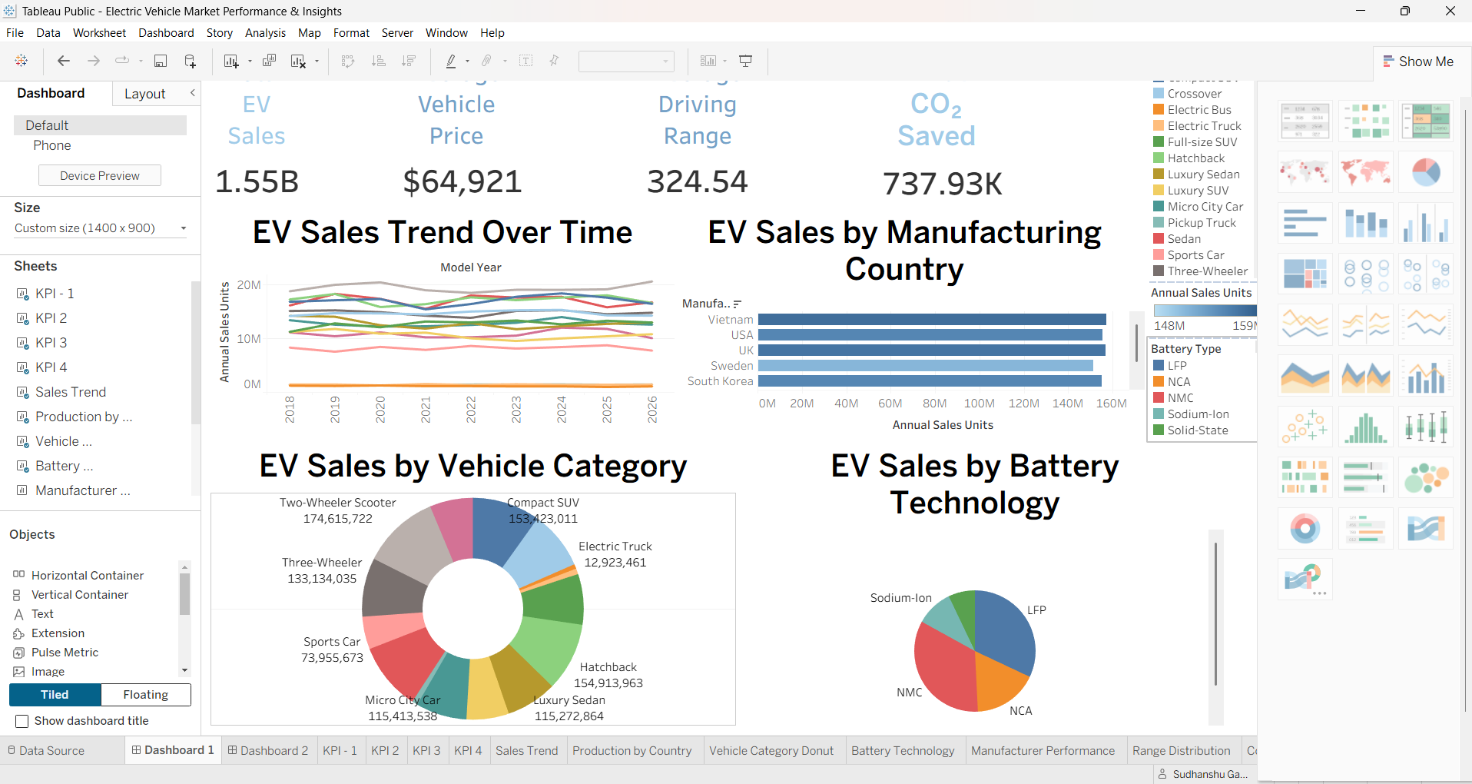
Figure A2. Second dashboard with manufacturer performance, driving-range distribution, country/category heatmap, and charging-efficiency scatter plot.


